BULK ORDER OF CARD INVENTORY

1st Step

Alert NagraID (card manufacturer) ahead of time before ordering and check the following:
- Make sure they can produce and deliver the requested quantity on time. NagraID is a very busy manufacturer and bulk orders can take months to manufacture.
- Discuss card design, specifications and requirements
- Discuss packaging design, specifications and requirements
- Have the card and packaging artwork technically ready (ask NagraID for help)
- Submit artworks for approval to network (VISA) via the issuing bank (FCB).
- Once artworks and language are approved, send the file to NagraID for proofing.
- Sign and approve card and packaging proof (make sure the color Pantone are correct)
- Request NagraID for a delivery date
- Discuss and approve price if not already quoted
- Send P.O. order to NagraID (always mention the quote # for recap in the P.O.)
- Make sure their secure FTP server is ready and online to receive card embossing files from FIS.
- Finally place order at FIS via CIMS (see details in Step 2 below)
NagraID contact: Beat Clerc at beatc@nagraid.com
Alert FIS (processor) before any bulk order to make sure everything is working or in case they need to test the system before placing an order. Once an order is placed, PAN numbers are being generated and become part of TransCash inventory. If a wrong file is being generated, it cannot be fixed and the PAN numbers are lost.
FIS contact: Prajwal Rao at prajwal.rao@fisglobal.com

2nd Step

Card order is done using the CIMS (Card Inventory Management System) tool provided by FIS.
Because of the dual card pack, we need to place 2 separate orders for the same amount of cards.
For Example, if we need to order 50 000 GPR dual packs, we will need to place 2 orders:
- 50 000 GPR Primary card (black)
- 50 000 GPR Secondary card (red)

The 2 orders need to be placed at the same time.
Once the 2 orders are placed on CIMS, FIS generates a card embossing file and sends it to NagraID via secure FTP transmission.
CIMS MANUAL ORDER PROCEDURE

PS: It is important to be updated on all new regulations regarding technical requirements of cards such as Pin & Stripe cards vs Magnetic cards to stay up to date.

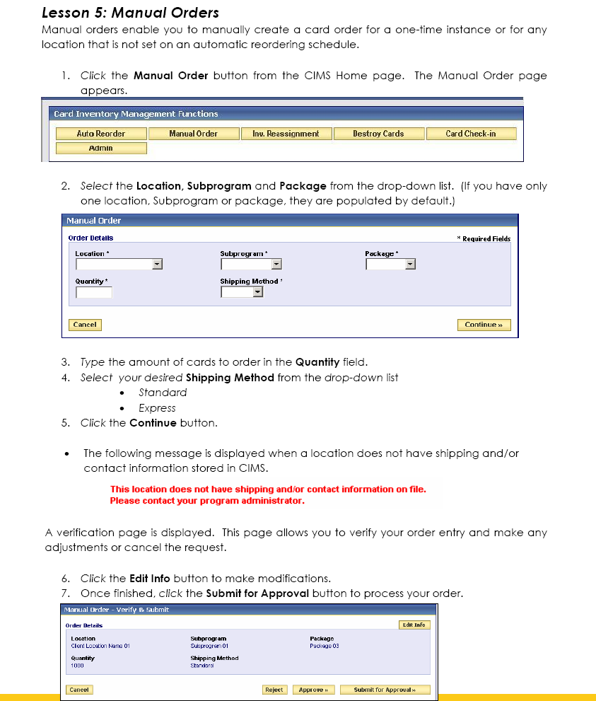
Note that TransCash is Bulk ordering. We need to make sure the store address has been pre-registered.


